GLOBAL DISASTER RESPONSE ANALYSIS

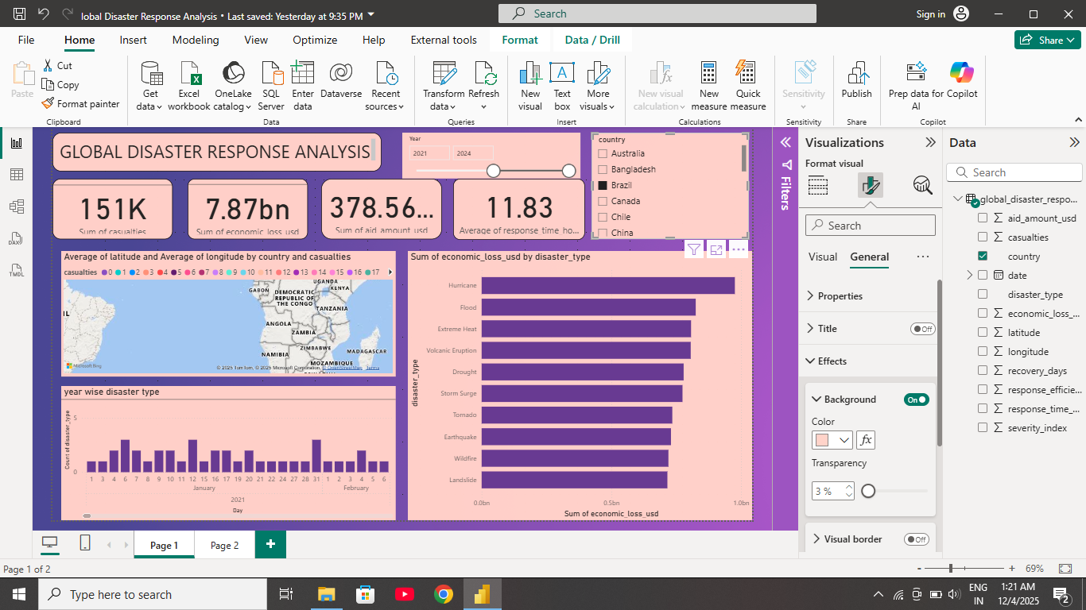

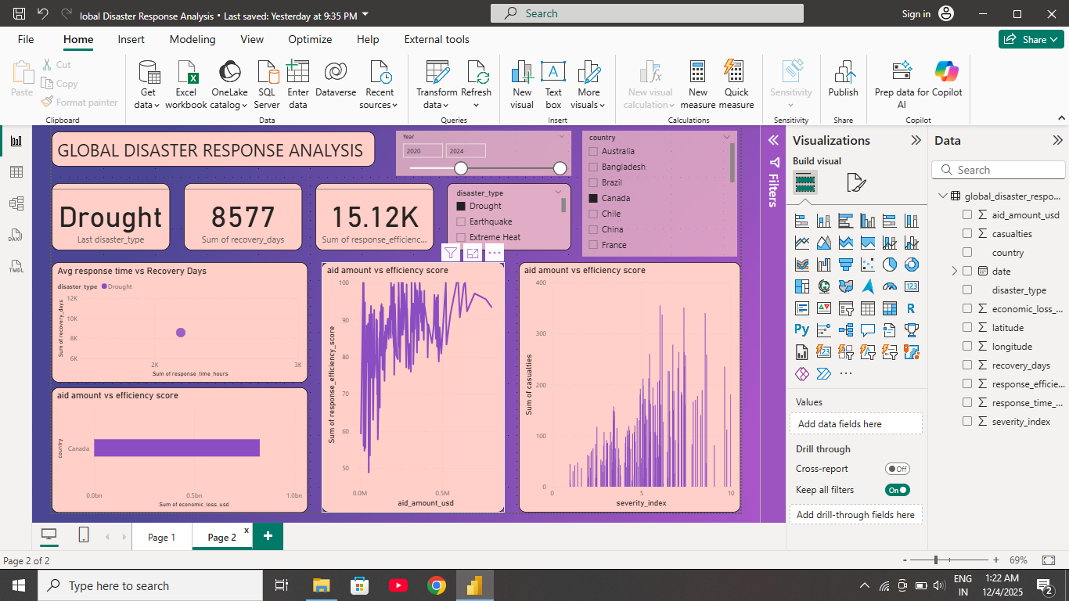

NAME- SHIVANI TULSHIDAS MUKHEAKR
BATCH- 10 JULY DA/DS

